Description

This college buddy system is designed to improve the socializing experiences of the students of INTI College Penang and to provide them another channel which enables them to take initiative in meeting new people, connecting all peers and seniors to form a giant network of relationships.

Before initializing the development process for this buddy system, data should be gathered to match the target audience's demands and ensure users are satisfied. In this case, the students' approval of thumb is crucial for this buddy system to be used or accepted prevalently among students in the campus.

The users will be able to register and sign up an account of their own and find friends through the search function and filter them to match their personal preferences. Once the user finds a person of interest, they can send a friend request to the person of interest and start chatting after the request has been accepted.

Data Analysis

* User Story Mapping

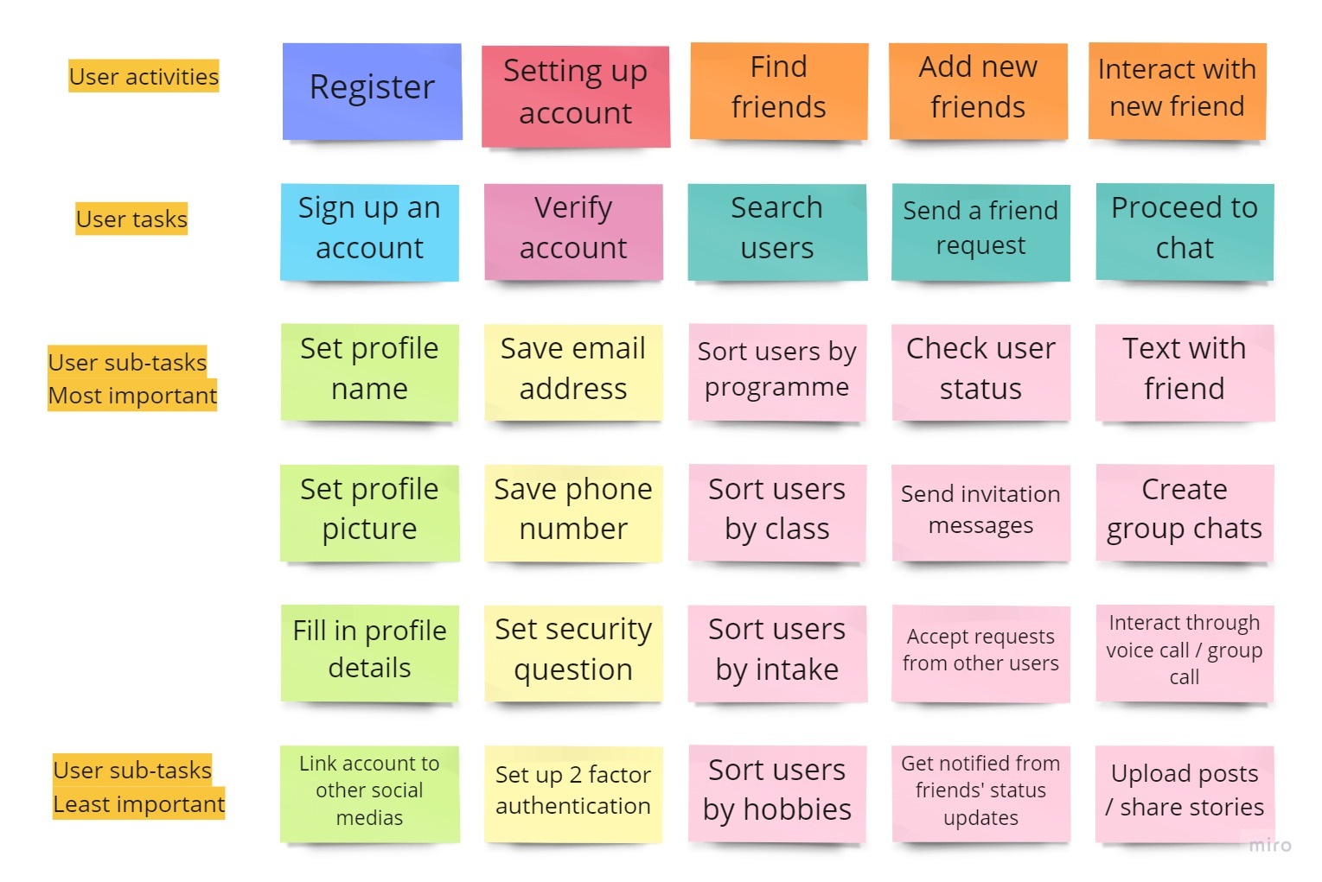

* 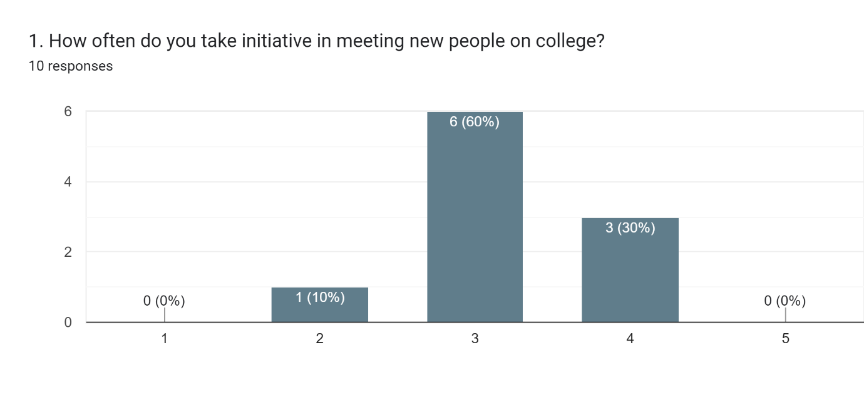User Feedback through Google Forms

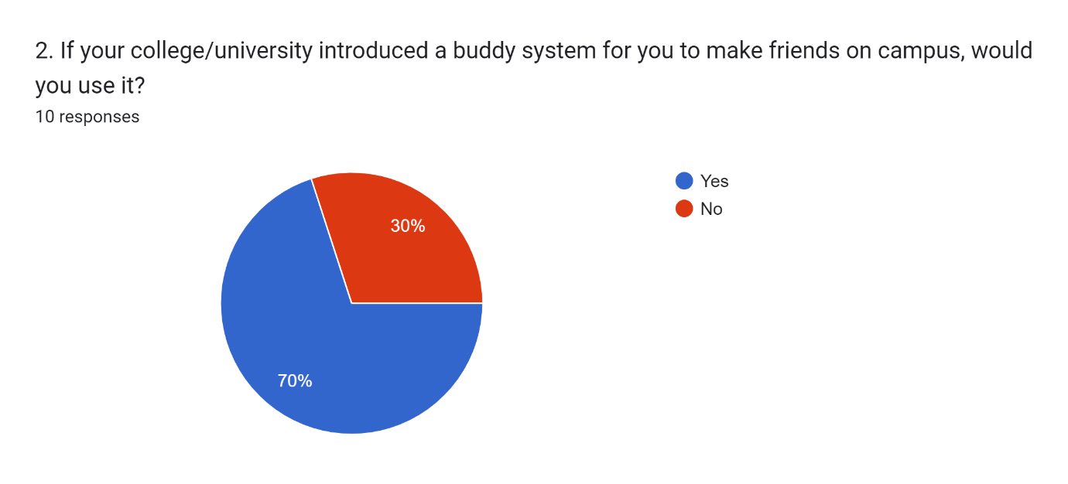By referring to the graph above, we can conclude that most of the participants have some sort of interest in meeting new people, socialise and make new friends.

70% of the participants are interested in using the college buddy system to further enhance their socialising experiences. While only 30% of the participants would rather communicate directly and meet through the campus than using the college buddy system to make new friends.

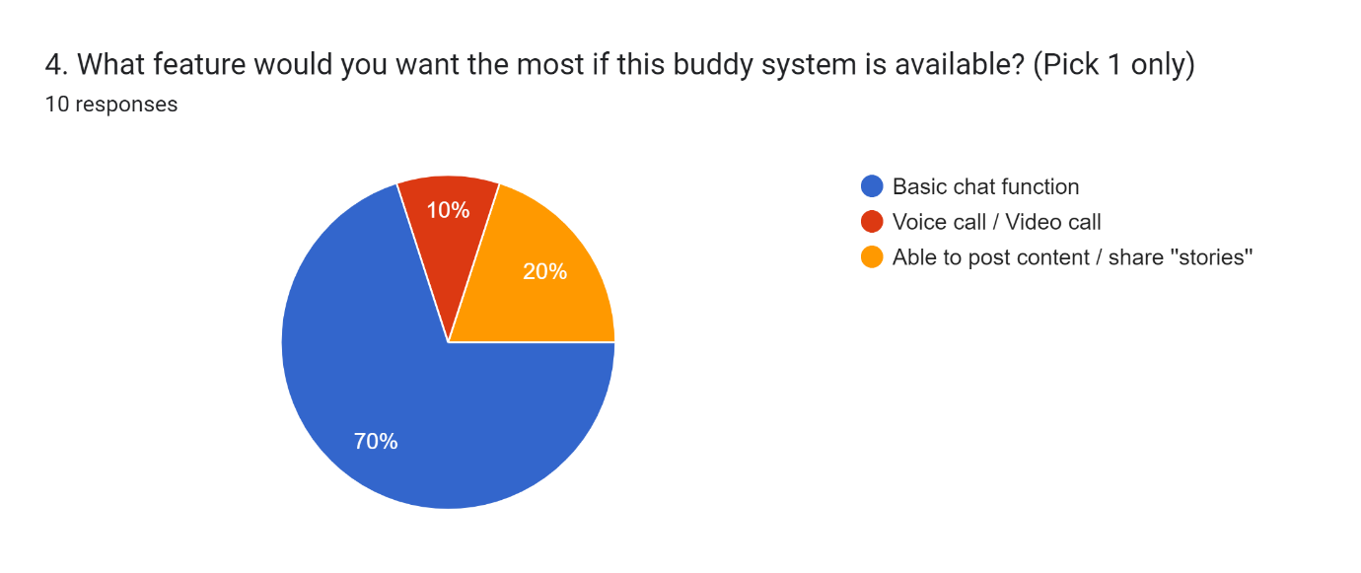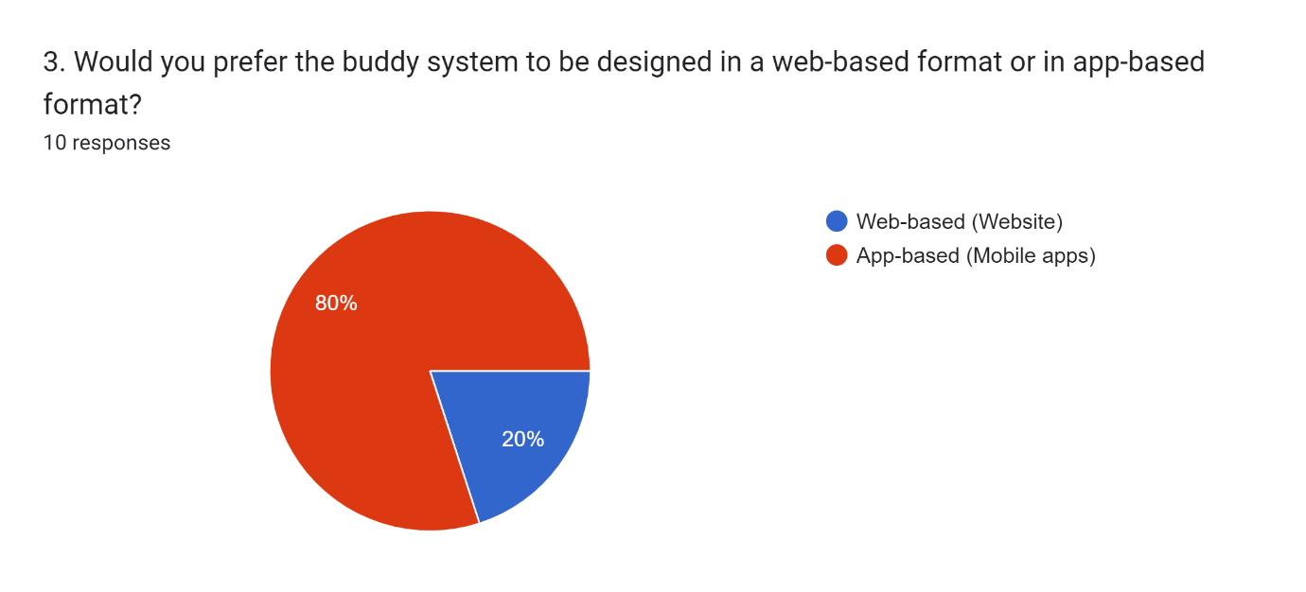Majority of the participants requested the college buddy system to be developed as a mobile application as they feel that mobile apps are more accessible and easier to navigate, even though they can access the college buddy system as a website through their mobile browser.

Since that there are better social media applications, the college buddy system’s purpose is not to outshine these major social media apps but to serve as a convenient basic app for the users, majority of the participants request that the college buddy system to have a chat function to communicate with their buddies easily through text messages.

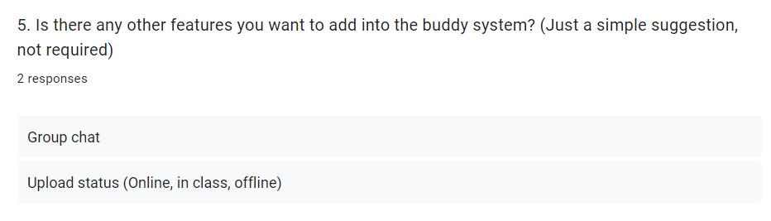To further seek new feature ideas to implement into the college buddy system, I have proposed the participants to give any inputs they can think of. Sadly, only a few of the participants managed to give their responses for this question. With that, this questionnaire has concluded. It has successfully gathered some data that could act as a simple guideline for the development of the college buddy system.

Vision

When the college buddy system is complete, it may not able to capture the target users’ attention in such a short time period. With the assistance from the college staff, they could help promote the buddy system to gain attention from the students. After that, students may find it as a convenient tool that lets them to connect with other people. They could use it to exchange contacts on class, while participating in events or even when they are on their break time, wandering around and found someone that caught their eye in the campus. In conclusion, I have high hopes for this college buddy system and could foresee it being used commonly among students in the future.